Boy Scout Camps by Council

Alamo Council
Bear Creek Scout Reservation (2½ hr travel) http://www.alamoareabsa.org/camping/bearcreek – 20 miles west of Kerville in the Texas Hill Country on a creek between limestone cliffs. Has two pools, one natural, one man-made. Activities include fishing, zip lining, hiking, mountain biking and others. Camp is suitable for Philmont shakedown hikes.
Mays Family Scout Ranch (2 hr travel) http://www.alamoareabsa.org/Camping/Mays/RentalRequest – This camp opened in 2015 and is located just south of San Antonio. It consists of 75 ac on the Medina River and is currently used for rustic camping. There are some campsites that have been developed. Hiking trails are available.
Capitol Area Council
Lost Pines (1 hr travel) http://www.bsacac.org/camping/our_camps/lost_pines - Yes, you’re familiar with Lost Pines, but as a refresher, available activities include: climbing tower, fishing, rifle & shotgun, archery and canoeing. Don’t forget about these activities!
Griffith League (1 hr travel) http://www.bsacac.org/activities/our_camps/griffith_ranch - This 5,000 acre camp is one of the few remaining land grants from the Republic of Texas. It’s a primitive site that requires small group camping and all units must use Leave No Trace camping guidelines. Strict camping/hiking requirements from Dec to May due to Toad mating season. No ground fires are permitted; cooking by camp stove/backpack stove only. The camp has 16 miles of casual and more rigorous hiking trails and is well suited for backpacking treks.
Alma McHenry (1 ½ hr travel) http://www.bsacac.org/activities/our_camps/alma_mchenry - primitive camping on 250 acres of pastureland with no defined campsites. The camp has a lot of oak trees and several private stocked fishing ponds. Drinking water is available but there are no bathroom facilities.
Green Dickson (2 hr travel) http://www.bsacac.org/activities/our_camps/green_dickson - 15 campsites, 6 latrines and one central shower facility/shelter with power. Drinking water is available. There is a 6 acre private stocked pond and large areas available for troop activities.
Roy D Rivers (1 hr travel) http://www.bsacac.org/activities/our_camps/roy_rivers - 400 acres of heavily forested, rugged terrain. Perfect for low impact wilderness camping and backpacking. Primitive-style camping, no defined campsites. Water is not available, no structures on the property.
Smilin’ V Ranch (½ hr travel) http://www.bsacac.org/activities/our_camps/smilinv - 91 acres of improved Hill Country ranch land, men's/women's restrooms and shower facilities. Non-potable well water; bring your own water. Large pavilion with picnic table seating for 200. Well suited for Camporee and Webelos Woods.
Circle 10 Council
Clements Scout Ranch (3 hr travel) http://circleten.org/clements-scout-ranch-trevor-rees-jones-scout-camp - Houses two Boy Scout camps located in the Piney Woods of East Texas:
  - Camp Meisenbach: Features 8 campsites with 2 pavilions. Located on Murchison Lake which offers 160 acres of fishing with several fishing docks and canoeing programs. The camp has 13 miles of hiking trails and 3 additional “Philmont” style campsites.
  - Camp Trevor Rees-Jones: Features stocked fishing lake, climbing tower, swimming pool and hiking trails.
Camp Constantine/Jack Furst Aquatics Base (3 ½ hr) http://circleten.org/camp-constantin-jack-d-furst-aquatic-base - 300+ acres and 6 miles of coastline on Possum Kingdom Lake. Weekend activities include hiking to Johnson Peak, rifle, shotgun, archery, canoeing, rowing, fishing and swimming in one of the clearest lakes in Texas.
East Texas Area Council
Camp Pirtle (4 ½ travel) http://www.etexscouts.org/camping/camp-pirtle - Nestled in the piney woods of East Texas, Pirtle is located on the banks of Lake Murval and has facilities for a wide range of activities from rifle, shotgun, archery ranges and climbing walls. Waterfront access to Lake Murval allows for a wide array of boating activities. Also available are a swimming pool, hiking trails, 14 campsites and much more.
Longhorn Council
Camp Tahuaya (1 hr travel) http://www.longhorncouncil.org/camps-properties/boy-scout-camps/camp-tahuaya - Camp Tahuaya is a beautiful, heavily forested 150 acre camp with the largest natural spring in Texas and a lake that is well stocked with trout. The camp has plenty of room for activities to include hiking, shotgun and rifle shooting, climbing and fishing.
Worth Ranch – ( 3 hr travel) http://www.longhorncouncil.org/camps-properties/boy-scout-camps/worth-ranch/ - Worth Ranch is located 60 miles west of Fort Worth on the Brazos River at the foot of Kyle Mountain. The historic stone and petrified wood buildings that encircle our parade ground showcase the rich and colorful history of Worth Ranch. Activities include water activities, climbing, fishing and swimming.

Sam Houston Area Council
El Rancho Cima (1 ½ hr travel) http://www.samhoustonbsa.org/el-rancho-cima - A variety of weekend camping activities are offered. For a nominal fee, troops can reserve a campsite and enjoy zip lining, shooting sports, fishing, hiking, horseback riding, climbing tower, and/or canoeing of a weekend experience. Units must provide certified instructors. Weekend camping is closed during the summer camp season.
Camp Brosig (2 hrs travel) http://www.samhoustonbsa.org/camp-brosig - A 92 ac weekend camping property. It has 20 campsites, pavilions, restrooms and a few showers. Ranger or camp master support may not be available at this camp.
Camp Bovay (2 hrs travel) http://www.samhoustonbsa.org/bovay-scout-ranch - A 1,498 acre camp. The campsites are surrounded by native Huisach and Bois-d’arc trees and sunsets that are absolutely breathtaking. Campsites have pavilions, restrooms, and showers. Weekend Camping is available to troops at Tellepsen Scout Camp. Tellepsen has eight campsites that accommodate 48 individuals per site. One shower and restroom facility will be available for every two campsites. Archery, rifle shooting, shotgun shooting and a climbing tower are available. The rifle range consists of 8 shooting stations for .22 rifles and an archery range. The climbing tower has two rappelling stations of 11 feet, 22 feet, 32 feet, and 41 feet.
South Texas Council
Karankawa (3 hr travel) http://southtexasbsa.org/about-us/properties/ - 130 ac camp includes 17 campsites, rustic cabins, and a residence house all equipped with modern restroom facilities. Program amenities include a swimming pool, a waterfront with canoes, rowboats, ski-boats, sailboats and sail boards, craft area, nature area and trails, archery, rifle, shotgun, and paintball ranges, a campfire amphitheater, and a COPE course. It includes a 300 person dining hall, office, health center, lakeside conference center. Programs are operated year round for Scouts and unit camping is available throughout the year.
Texas Southwest Council
Camp Sol Mayer (2 ½ hrs travel) http://tswcbsa.org/pages/sol-mayer - 300 ac camp on the San Saba River. Formerly known as Brown or Opp Ranch. They have aquatic programs, outdoor skills, and climbing tower.
Baden Powell Park (3hrs travel) http://tswcbsa.org/pages/Baden-Powell-Park - Located in the City Limits of San Angleo on Lake Nasworthy. No other information is listed.
Texas Trails Council
Camp Billy Gibbons (1 hr, 53 min) http://texastrailsbsa.com/camping.html - Camp Billy Gibbons is located on Brady Creek 13 miles south of Richland Springs, TX. The camp is operated year-round and is used not only for summer camp but for weekend camping by Scout Troops The ground is very rocky. There are hiking trails, and other typical summer camp type opportunities. Water and electricity are available only for official Council activities. A permit is required to use the camp. Contact the Texas Trails Council office to make a reservation.

Texas State Parks within 3 hours of Cedar Park – with camping
Walk-in Tent Campsites:
- Colorado Bend State Park (1 ½ hr. travel) http://tpwd.texas.gov/state-parks/colorado-bend - Activities include primitive camping, hiking, mountain biking, fishing, swimming, paddling, birding and wildlife viewing. The trail system offers 32 miles of multiuse routes with something for explorers of every skill level. This area of the river is characterized by slow moving water through the beautiful canyon lands of the Colorado River. The park rents single and double sit-on-top kayaks and offers a 10 percent discount to Texas State Park Pass holders.
- Dinosaur Valley State Park (2 ½ hr. travel) http://tpwd.texas.gov/state-parks/dinosaur-valley - Activities include camping, hiking, swimming, geocaching, fishing and viewing dinosaur tracks. Regular and backpack campsites are available. Explore 20 miles of trails.

- Enchanted Rock (1 ½ hr. travel) http://tpwd.texas.gov/state-parks/enchanted-rock - Activities include hiking, backpacking rock climbing, geocaching. (You cannot swim here or ride bikes on the trails. The Summit Trail may close in wet weather.)

- Government Canyon State Natural Area (2 hrs. travel) http://tpwd.texas.gov/state-parks/government-canyon - Government Canyon State Natural Area has more than 40 miles of hiking and biking trails that range from remote rugged canyon lands to gently rolling grasslands.

- Guadalupe River State Park (2 hrs. travel) http://tpwd.texas.gov/state-parks/guadalupe-river - The park has 4 miles of river frontage and is located in the middle of a 9-mile stretch of the Guadalupe River. Activities include canoeing, fishing, swimming, tubing, hiking and camping. The park recently opened a 5.3-mile equestrian trail that is also open to mountain biking. No equestrian camping is available at the park. Opportunities also exist for less vigorous pursuits, such as bird watching and nature study.

- Hill Country State Natural Area (2 ½ hrs. travel) http://tpwd.texas.gov/state-parks/hill-country - Activities center around 40 miles of designated, multiuse trails. The park offers a back country setting for primitive camping, backpacking, hiking, and nature viewing.

Hike-In/Backpacking Campsites:
- Bastrop State Park (1 hr. travel) http://tpwd.texas.gov/state-parks/bastrop - Activities include backpacking, camping, canoeing (park rents canoes), swimming (pool), wildlife viewing and hiking Fishing - Bring your pole and enjoy some fishing along the banks of Bastrop State Park Lake. If you can’t reach them from the bank, you can rent one of the canoes and relax out in the open waters.

- Cedar Hill State Park (3 hrs. travel) http://tpwd.texas.gov/state-parks/cedar-hill - The park features 355 mostly wooded campsites with a shade shelter over some of the picnic tables. Each site has water, electricity, a fire ring, a lantern pole and a picnic table. All campsites are within walking distance of restrooms with hot showers. Additionally, there are 30 primitive campsites. There are two lighted fishing jetties. Lake fishing includes largemouth black bass, crappie and catfish. The park has a gravel swimming beach surrounded by picnic tables with grills.

- Colorado Bend State Park (1 ½ hrs. travel) http://tpwd.texas.gov/state-parks/colorado-bend - Activities include primitive camping, hiking, mountain biking, fishing, swimming, paddling, birding and wildlife viewing. The trail system offers 32 miles of multiuse routes with something for explorers of every skill level. This area of the river is characterized by slow moving water through the beautiful canyon lands of the Colorado River. The park rents single and double sit-on-top kayaks and offers a 10 percent discount to Texas State Park Pass holders.

- Fairfield Lake State Park (1 hr. travel) http://tpwd.texas.gov/state-parks/fairfield-lake - Activities include camping, backpacking, hiking, horseback riding on approximately 15 miles of day-use equestrian trails, boating on a 2,400-acre lake, fishing, and lake swimming in a large, buoyed sandy area. The lake is warmed by the TXU Big Brown power plant. Because of the warm water, people come from all over Texas to enjoy fantastic winter fishing opportunities. From November through February, tournaments are held every weekend.

- Goliad State Park (2 ½ hrs. travel) http://tpwd.texas.gov/state-parks/goliad - The park complex, located on the San Antonio River, contains a refurnished restoration of a Spanish Colonial Era Mission. Activities include camping, picnicking, hiking, fishing. The park offers a floating dock and river access for kayaks and canoes, and is a take-out point for the Goliad Paddling Trail.

- Inks Lake State Park (1 hr. travel) http://tpwd.texas.gov/state-parks/inks-lake - Activities include camping, backpacking, swimming, boating, fishing and hiking. Since Inks Lake stays at a constant level, droughts do not affect water-related activities.

- Lake Somerville State Park (1 ½ hrs. travel) http://tpwd.texas.gov/state-parks/lake-somerville - Both the Birch Creek and Nails Creek units of Lake Somerville State Park offer camping, boating, fishing, hiking, volleyball, horseshoes, basketball and backpacking. More than 20 miles of trail are open to hikers and backpackers. The Lake Somerville Trailway, located around the west end of the reservoir, connects Birch Creek State Park with Nails Creek State Park via 13 miles of trails for hiking, mountain biking, horseback riding and backpacking.

- Lost Maples State Park (3 hrs. travel) http://tpwd.texas.gov/state-parks/lost-maples - Activities include camping, backpacking, sightseeing, hiking, fishing and swimming.

- Mother Neff State Park (1 ½ hrs. travel) http://tpwd.texas.gov/state-parks/mother-neff - Activities include camping, hiking, backpacking, fishing from the riverbank, and wildlife observation.

- Pedernales Falls State Park (1 ½ hrs. travel) http://www.bing.com/search?q=pedernales+falls+state+park&qs=RQ&sk=AS1&pq=pedernales+state+park&sc=8-21&sp=2&cvid=fcf08dae3757484f8b03b6e3d0eb205f&FORM=QBRE - Activities include camping, hiking, river swimming, tubing and fishing. There are both drive up and backpacking campsites available. The easy, 7-mile Wolf Mountain Trail wraps around Tobacco and Wolf Mountains, winding along the small canyons created by Mescal and Tobacco creeks.

SCOUT CAMPS AND ACCOMPANYING MAP OF THE CAMP

Alamo Council
1. Bear Creek Scout Reservation – west of Kerville. In the Texas Hill Country on a creek. Has a pool. In a valley between cliffs. Fishing is possible.
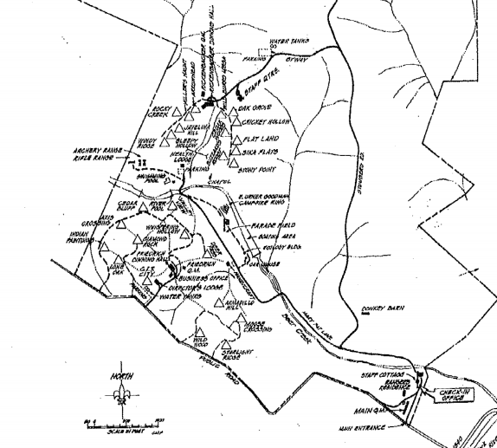

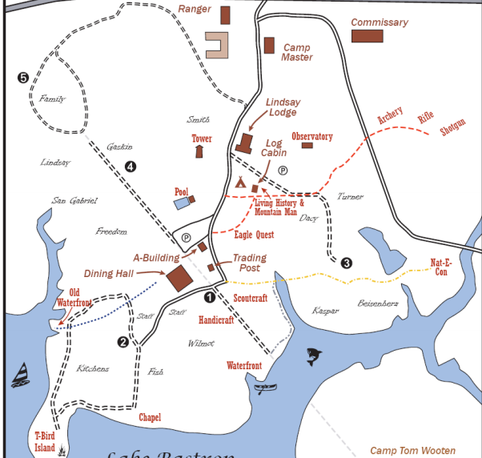
Capitol Area Council
3. Lost Pines

4. Griffith League (nearly 5000 ac) - a map of the hiking trails.
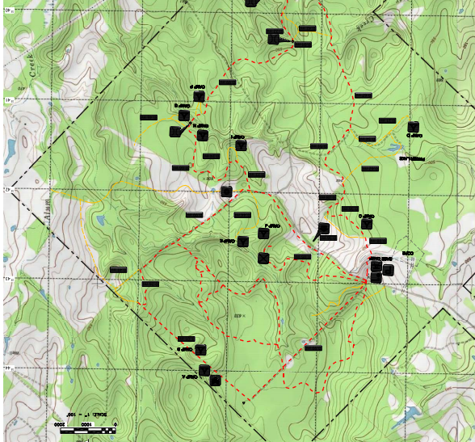

Green Dickson:
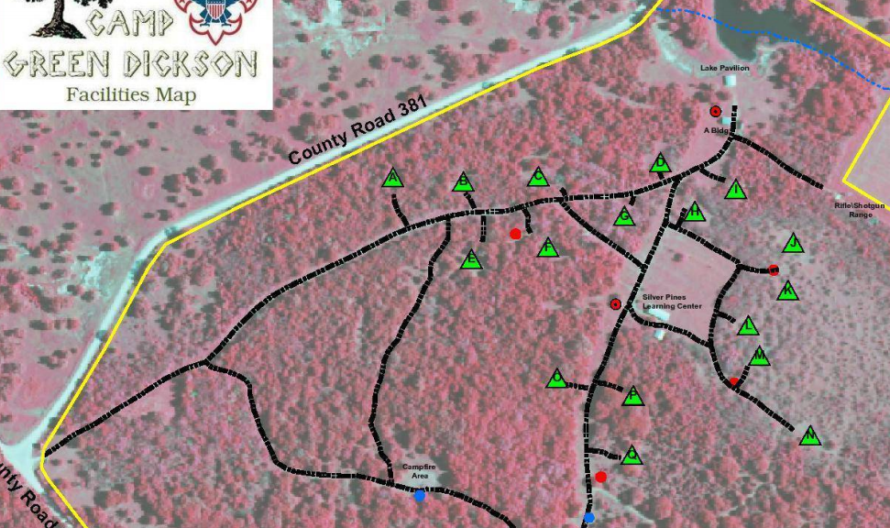
Roy D Rivers: 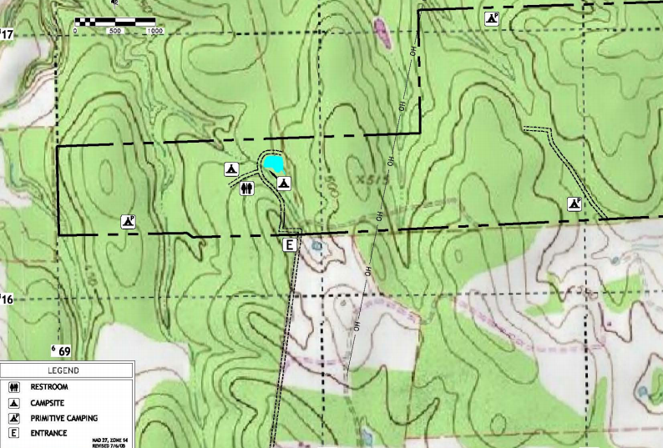

Circle 10 Council
Clements Scout Ranch:
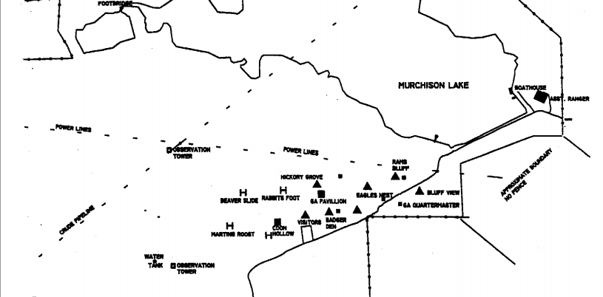

Trevor Rees-Jones:
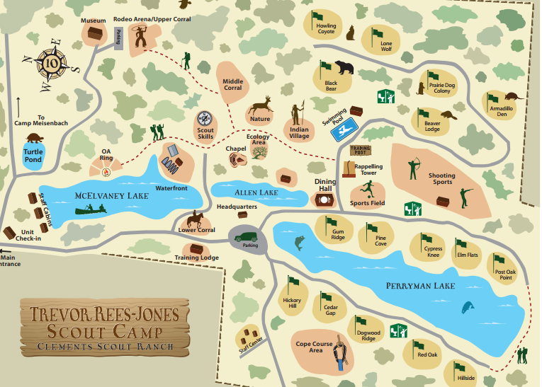

Camp Constantine:
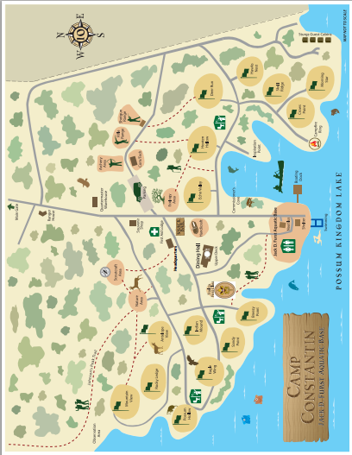

East Texas Area Council
Camp Pirtle:
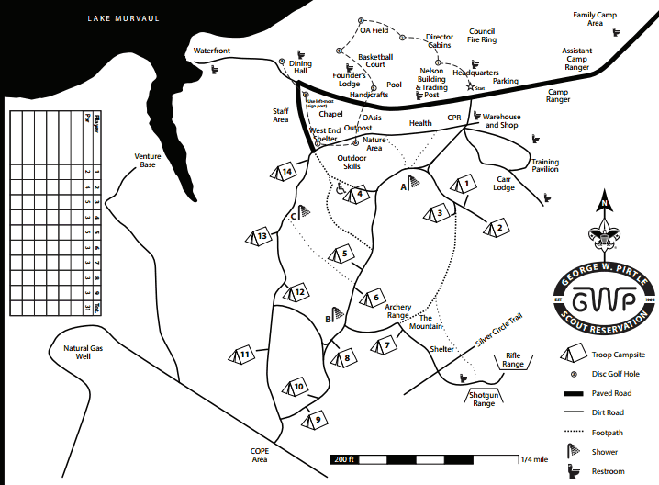

Longhorn Council
Camp Tahuya:
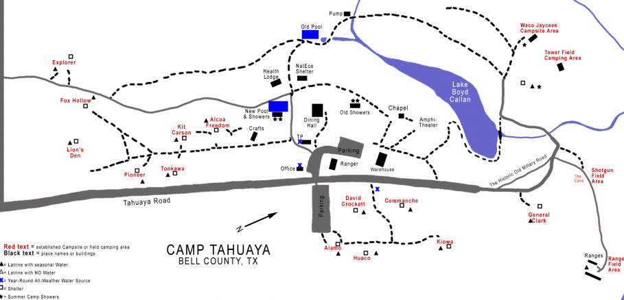

Worth Ranch:
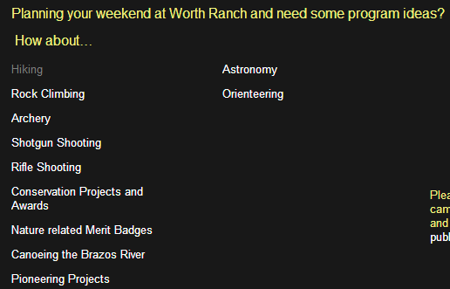
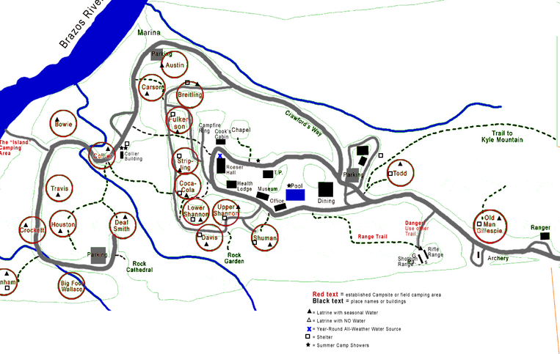

Sam Houston Area Council
Camp Strake no map available for Camp Strake which is being moved.
El Rancho Cima
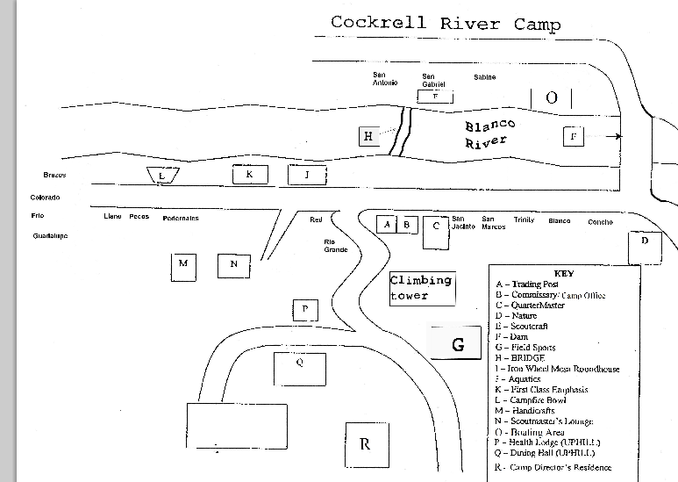
Cockrell River Camp area of El Rancho Cima:

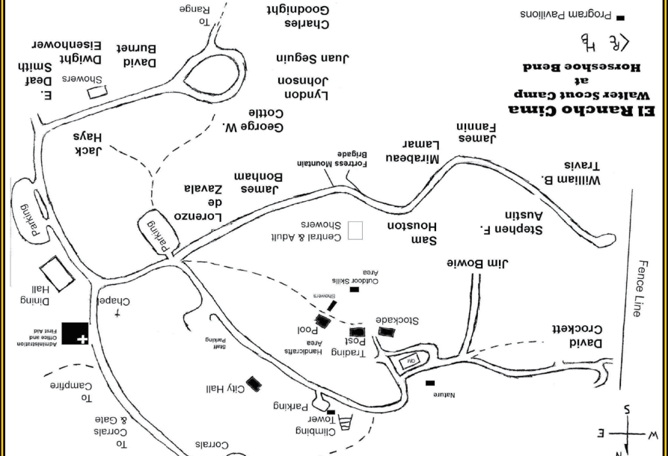
Walter Scout Ranch at Horseshoe Bend area of El Rancho Cima

Camp Brosig:
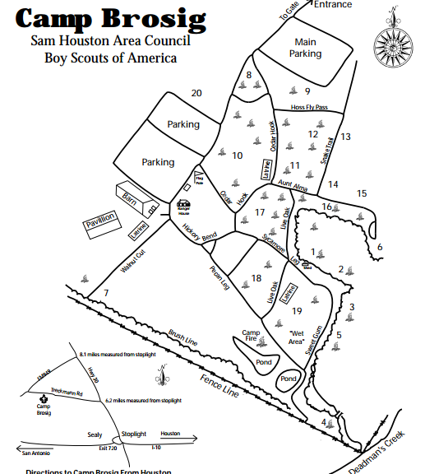

Camp Bovay
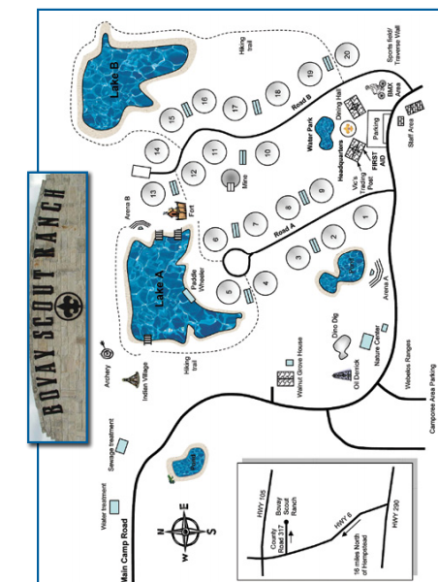

South Texas Council
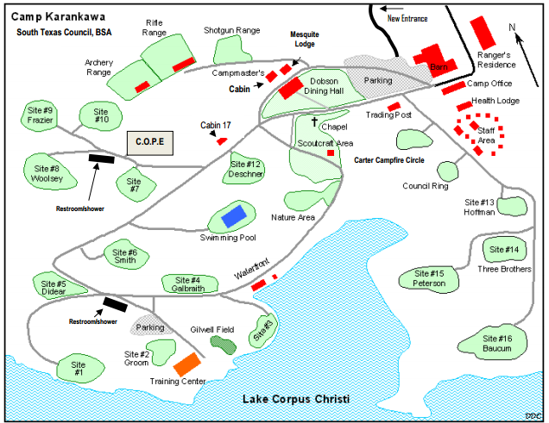
Camp Karankawa:

Texas Southwest Council
Camp Sol Mayer:
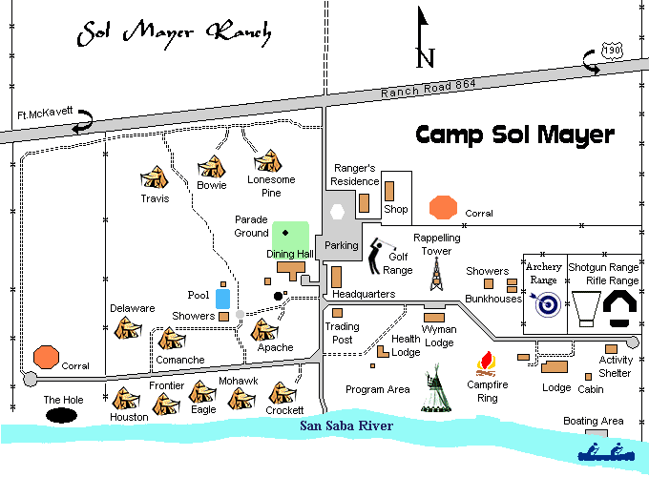

Baden Powell Park (Located in the City Limits of San Angleo on Lake Nasworthy):
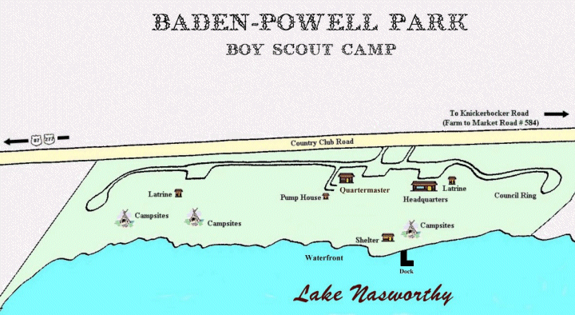

Texas Trails Council
Camp Billy Gibbons:
